A72-AM,S-Peru-Vicús Culture-Gold Figurine-Female-200 BCE-600. AD/CE

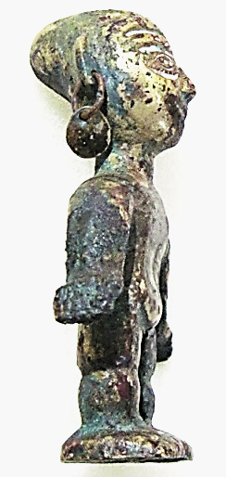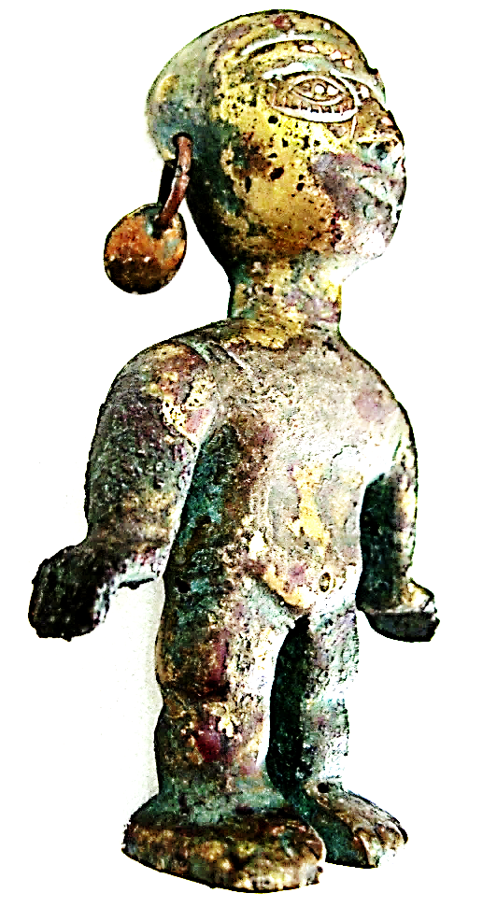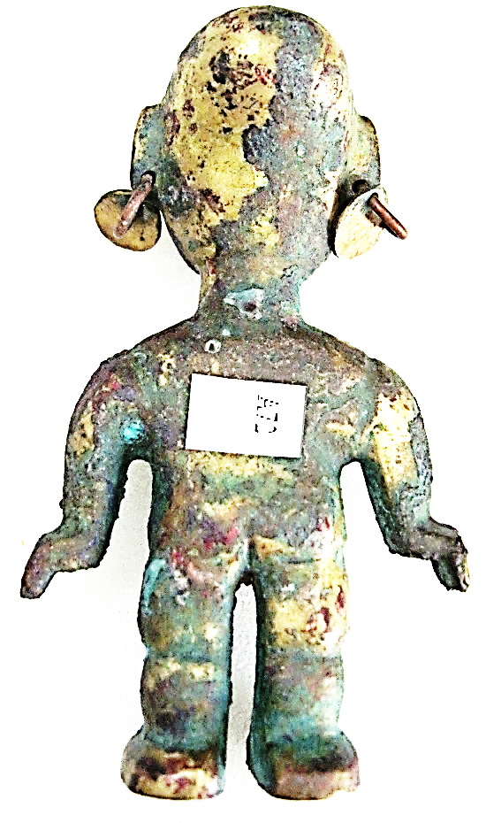 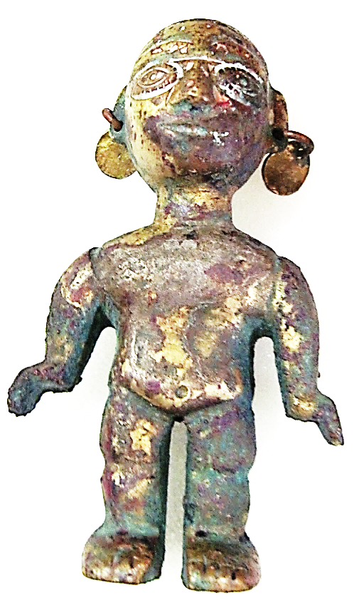 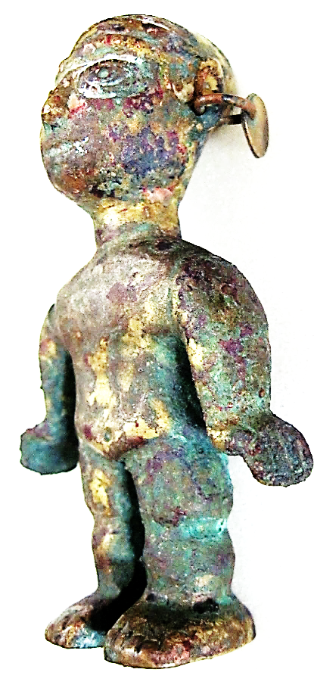 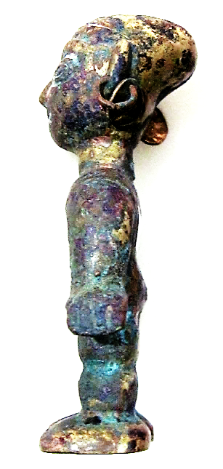

Figs. 1-6. Peru-Vicús Culture-Gold Figurine-Female-200 BCE-600 AD/CE

**Case no.: 7**

**Accession Number: A 72**

**Formal Label: Peru-**Vicús Culture-Gold Figurine-Female-200 BCE-600 AD/CE

**Display Description:**

This gilded gold nude female statuette has been named “Venus de Frías” and represents a young woman in a formalized posture. She is standing erect with her hands in a gesture of maintaining balance that suggests she is either performing a dance or an acrobatic movement. It has been suggested that the original “Venus de Frías” statuette discovered found in the Cerro Callingará of the District of Frías of the Province of Ayabaca in 1956 is considered by many the most important piece of gilded gold of Pre-Hispanic Peru. This figurine is unique as being the only one so far discovered that is a “twin” to the original “Venus de Frías.”

The Vicús culture (200 BCE-400 AD/CE) developed in Peru´s northwestern coastal area, the Piura Region, which is bordered to the north by the Tumbes Region and Ecuador, to the east by Cajamarca Region, to the south by the Lambayeque Region, and to the west by the Pacific Ocean. The center of the Vicús culture has been identified as Cerro Vicús (50 km east of the city of Piura), and includes the famous site of Loma Negra. The territory of the Piura Region has many climate variations due to its geographical location. It is just 4 degrees south of the equator, yet receives two ocean currents at the same time: the cold Humboldt Current (13-20 °C 55-68 F) and the warm El Niño Current (20-27 °C, 68-80 F). This makes the Piura Region a land that is both tropical and arid at the same time, “The Land where the Tropics meets The Desert.” Theories raised by Clifford Evans and Betty Meggers suggest a possible Ecuadorian origin of the Vicús culture in the vicinity of Valdivia.

Vicús metalworking was characterized by using the technique of gilding, plating, and hammering. The technique of gilding copper consisted in applying a patina of gold on figurines of copper like the present example. It is suggested that the gilding thickness of the areas remaining gilded of the figurine under discussion was originally ~2 µm and that the areas that have been corroded were originally ~0.5 µm (see Cesareo 2013: 896).

**LC Classification:** GN562.V5

**Date or Time Horizon:** 200 BCE-600. AD/CE

**Geographical Area:** NW Peru

**Map, GPS coordinates:** [4.99°S 80.41°W](https://tools.wmflabs.org/geohack/geohack.php?pagename=Piura_Region&params=-4.99_N_-80.41_E_type:adm1st_region:PE)

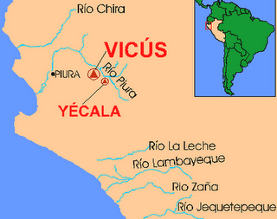 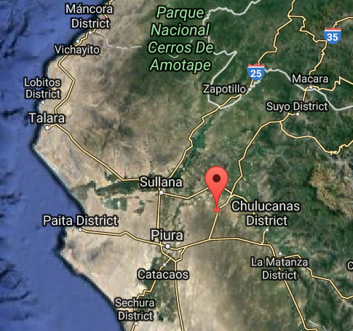

Figs. 7-8. Map of NW Peru showing location of the Cerro Vicús. Fig. 7: <http://1.bp.blogspot.com/_rMKJIW2qoEg/SmKRAWtj6ZI/AAAAAAAAAyU/KduaiJKyFYw/s320/CULTURA+VICUS+N%C2%BA+5.png>. Fig. 8: Map of NW Peru showing location of the Cerro Vicús at [4.99°S 80.41°W](https://tools.wmflabs.org/geohack/geohack.php?pagename=Piura_Region&params=-4.99_N_-80.41_E_type:adm1st_region:PE).

**Cultural Affiliation:** Vicús

**Media:** Gilded gold over copper.

**Dimensions:** 3.2 in, 81.25 mm

**Weight: 202 gm, 7 oz**

**Condition: original**

**Provenance:** Old South American Collection

**Discussion:**

Several details of the art and architecture of the Vicús culture link it with the Moche culture as well as influences radiating from Ecuador. Among the rich grave goods are hand-modeled ceramics with negative, or resist, decoration depicting human and animal forms. Some show similarities to contemporary late Chorrera ceramics produced in Ecuador, while others resemble styles made by more southern peoples.

Motifs in Vicús metal artefacts are more diverse than in its ceramics, and in these motifs they resemble the ornamental motifs of the Moche culture. Also, the technique of making metal artefacts is similar to that in the nuclear areas of the Moche culture. Despite these resemblances, Vicús metal artefacts are of a local origin, and a developing trade in metal objects marginalized the trade in ceramics.

During the mid Vicús period (ca. 100 BCE-100 AD/CE) in Peru's upper Piura Valley the dead were buried in shaft-and-chamber tombs as deep as twenty-nine feet, perhaps to protect the interred gilded gold artifacts from looters. The present example may have come from one of these deep graves.

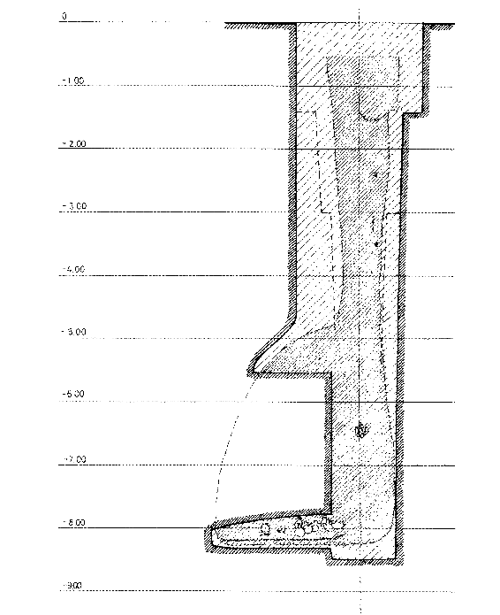 [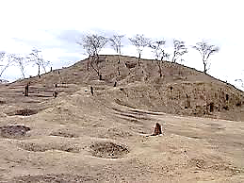](http://1.bp.blogspot.com/-Gzo_YPylDR8/TySD5Aj9lrI/AAAAAAAAHnc/I5ch5LFF2Xw/s1600/vicus.bmp)

Fig. 9. Side view of a boot-shaped well grave, from Disselhoff 1971.

Fig. 10. A Vicús mound located in the Hacienda de Pabur, Chulucanas, Morropón Province showing the depressions made by looters. From <http://1.bp.blogspot.com/-Gzo_YPylDR8/TySD5Aj9lrI/AAAAAAAAHnc/I5ch5LFF2Xw/s400/vicus.bmp>

The process of gilding copper and measuring the thickness of the gilding has been investigated for the Vicús culture and the following results have been produced. “Alloys from Vicús and Frías cultures in the Museo Municipal Piura and Museo Larco, Lima, of a gilded copper feline head with sequins, shows a gilded lamina, which from the XRF spectrum is possibly Cu–Au tumbaga” (Cesareo 2013: 896).

.

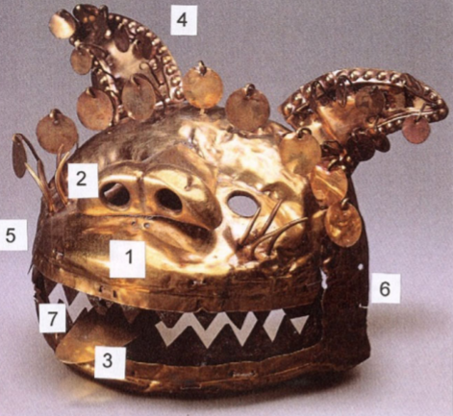

Fig. 11. Golden feline head with sequins, teeth, and tongue. The teeth are made of copper, with the following composition: Cu = 98.5 %, As = 1.5 %. Area 1, just above the lips, is possibly on Cu–Au tumbaga. From Cesareo 2013: 896, Fig. 9.

“Successively, two objects from Vicús culture were analyzed in Museo Larco, Lima. Both from the altered Cu(Kα/Kβ ) and Au(Lα/Lβ ) ratios, it was deduced that the two sheets are on gilded copper. The following Au thickness was determined: 2 µm and < 0.5 µm, respectively” (Cesaro 2013: 896).

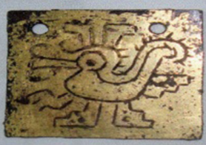 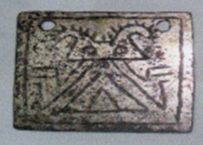

Fig. 12. Two sheets on gilded copper from the Larco Museum (ML100554 and ML 100555). From Cesareo 2013: 896.

The Au of the gilding of the figurine under discussion (Figs. 1-6) here has obviously been corroded in several places as in ML100554 and ML100555 above. It is suggested that since the gilding process was uneven, the thinner gilding areas were worn off with handling, leaving the thicker and better bonded Au areas intact. Based on the results above it is suggested that the gilding thickness of the areas remaining gilded of the figurine under discussion was ~2 µm and that the areas that have been corroded were ~0.5 µm, which corresponds to the results for ML100554 and ML100555 (see Cesareo 2013: 896).

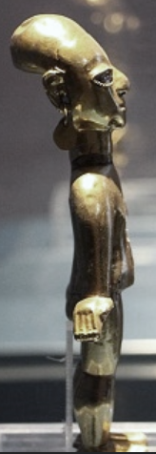 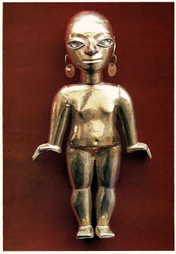[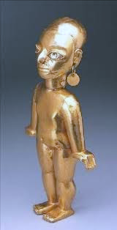](http://2.bp.blogspot.com/-f9vl7zsLf5c/TySAllQtNmI/AAAAAAAAHnM/d16pBhcZTaU/s1600/venus+de+fr+ias.bmp)

Figs. 13-15. The original "Venus de Frías" statuette of naked female figure, H 15.4 cms, weight 60 gm, gilded in 24 carat Au. She probably came from a high ranking nobility, since it was customary to deform the heads of children to differentiate them from commoners. Her head is articulated with platinum bushings that allows it to be removed. Her hands are in a gesture that suggests either a ritual dance or an acrobatic performance. Her earrings are perforated discoidal Au sequins. She was found in the Cerro Callingará of the District of Frías of the Province of Ayabaca in 1956. This figurine was previously in the Museo **Municipal** Lambayeque. Today it is in the **Sala Frías with other gold objects in the** new Museo **Municipal Vicús**, Piura. Left photo: https://1.bp.blogspot.com/-aHqR08pPe6E/WWthbByrkLI/AAAAAAAAkSI/L-sXunDkTbY4DCpS2tvyFis4ZGVYwdV6QCEwYBhgL/s1600/596a864cdcc88.jpeg. Center photo: plebs.http://3.bp.blogspot.com/_rMKJIW2qoEg/SmKQzpowg_I/AAAAAAAAAyM/2f6ENffiNG0/s320/CULTURA+VICUS.+VENUS+DE+FRIAS.jpg. Right photo: http://2.bp.blogspot.com/-f9vl7zsLf5c/TySAllQtNmI/AAAAAAAAHnM/d16pBhcZTaU/s1600/venus+de+fr+ias.bmp

**References:**

Cesareo, Roberto, *et al*. 2013. **“**Multilayered artifacts in the pre-Columbian metallurgy from the North of Peru,” *Applied Physics A: Materials Science & Processing*, Dec. 15, 113:889–903. DOI 10.1007/s00339-013-7738-8.

Disselhoff. Hans D. 1971. *Vicus: Eine neu entdeckte altperuanische Kultur*. Monumenta Americana Bd. 7. Berlin: Mann.

Giannoni, Daniel and Cecilia Bakula. 1987. *Vicús*, Colleccion Arqueologica. Lima: Museo Banco Central de Reserva del Peru.

Makowski, Krzysztof, Christopher B. Donnan, Ivan Amaro Bullon, Luis Jaime Castillo, Magdalena Diez Canseco, Otto Elespuru. 1994. *Vicús*. Lima: Banco de Credito del Peru.